

# IMAGE SCRAPING AND CLASSIFICATION PROJECT

Submitted by:

# AKSHAY DINESH SHAH

**ACKNOWLEDGMENT**

I express my sincere gratitude to Flip Robo Technologies for giving me the opportunity to work on this project on Malignant Comment Classifier using machine learning algorithms and Deep Learning libraries.

I acknowledge google, medium.com, and analytics vidya for providing me with invaluable knowledge and insights into what image classification and the role of Deep Learning processing tools and techniques in identifying them and in helping build models to classify

Input images.

# INTRODUCTION

Images are one of the major sources of data in the field of data science and AI. This field is making appropriate use of information that can be gathered through images by examining its features and details. We are trying to give you an exposure of how an end-to-end project is developed in this field.

The idea behind this project is to build a deep learning-based Image Classification model on images that will be scraped from e-commerce portal. This is done to make the model more and more robust.

### Problem Statement:

This task is divided into two phases: Data Collection and Mode Building.

**Data Collection Phase:** In this section, you need to scrape images from e-commerce portal, Amazon.com. The clothing categories used for scraping will be:

* Sarees (women)
* Trousers (men)
* Jeans (men)

You need to scrape images of these 3 categories and build your data from it. That data will be provided as an input to your deep learning problem. You need to scrape minimum 200 images of each category. There is no maximum limit to the data collection. You are free to apply image augmentation techniques to increase the size of your data but make sure the quality of data is not compromised.

Remember, in case of deep learning models, the data needs to be big for building a good performing model. More the data, better the results.

**Model Building Phase:** After the data collection and preparation is done, you need to build an image classification model that will classify between these 3 categories mentioned above. You can play around with optimizers and learning rates for improving your model’s performance.

# ANALYTICAL FRAMING

The project begins with data collecting phase. We have scraped the clothing images from “Amazon.com”. The 3 categories are whose data is scraped is “Sarees”, “Trousers” and “Jeans”. First, we have scraped link to those images using Selenium framework and then created directories to download and save scraped images.

The categories are defined as **Jeans: 0, Sarees: 1, Trousers: 2.**

We collected the data from difference e-commerce website, [www.Amazon.in.](http://www.Amazon.in/) The data is scrapped using Web scraping technique and the framework used is Selenium. We have scraped 400 images for each category i.e., total of 1200 images are collected. Then I have created a directory to download images.

After collecting the data, we next do training of the data. For that firstly, we created a main called “Train” and “Test” and we have further divided data into train and test data where train data consists of 1200 images and test data consists of 216 images.

**Visualization of Images**

We have used matplotlib. Image library to display images downloaded.

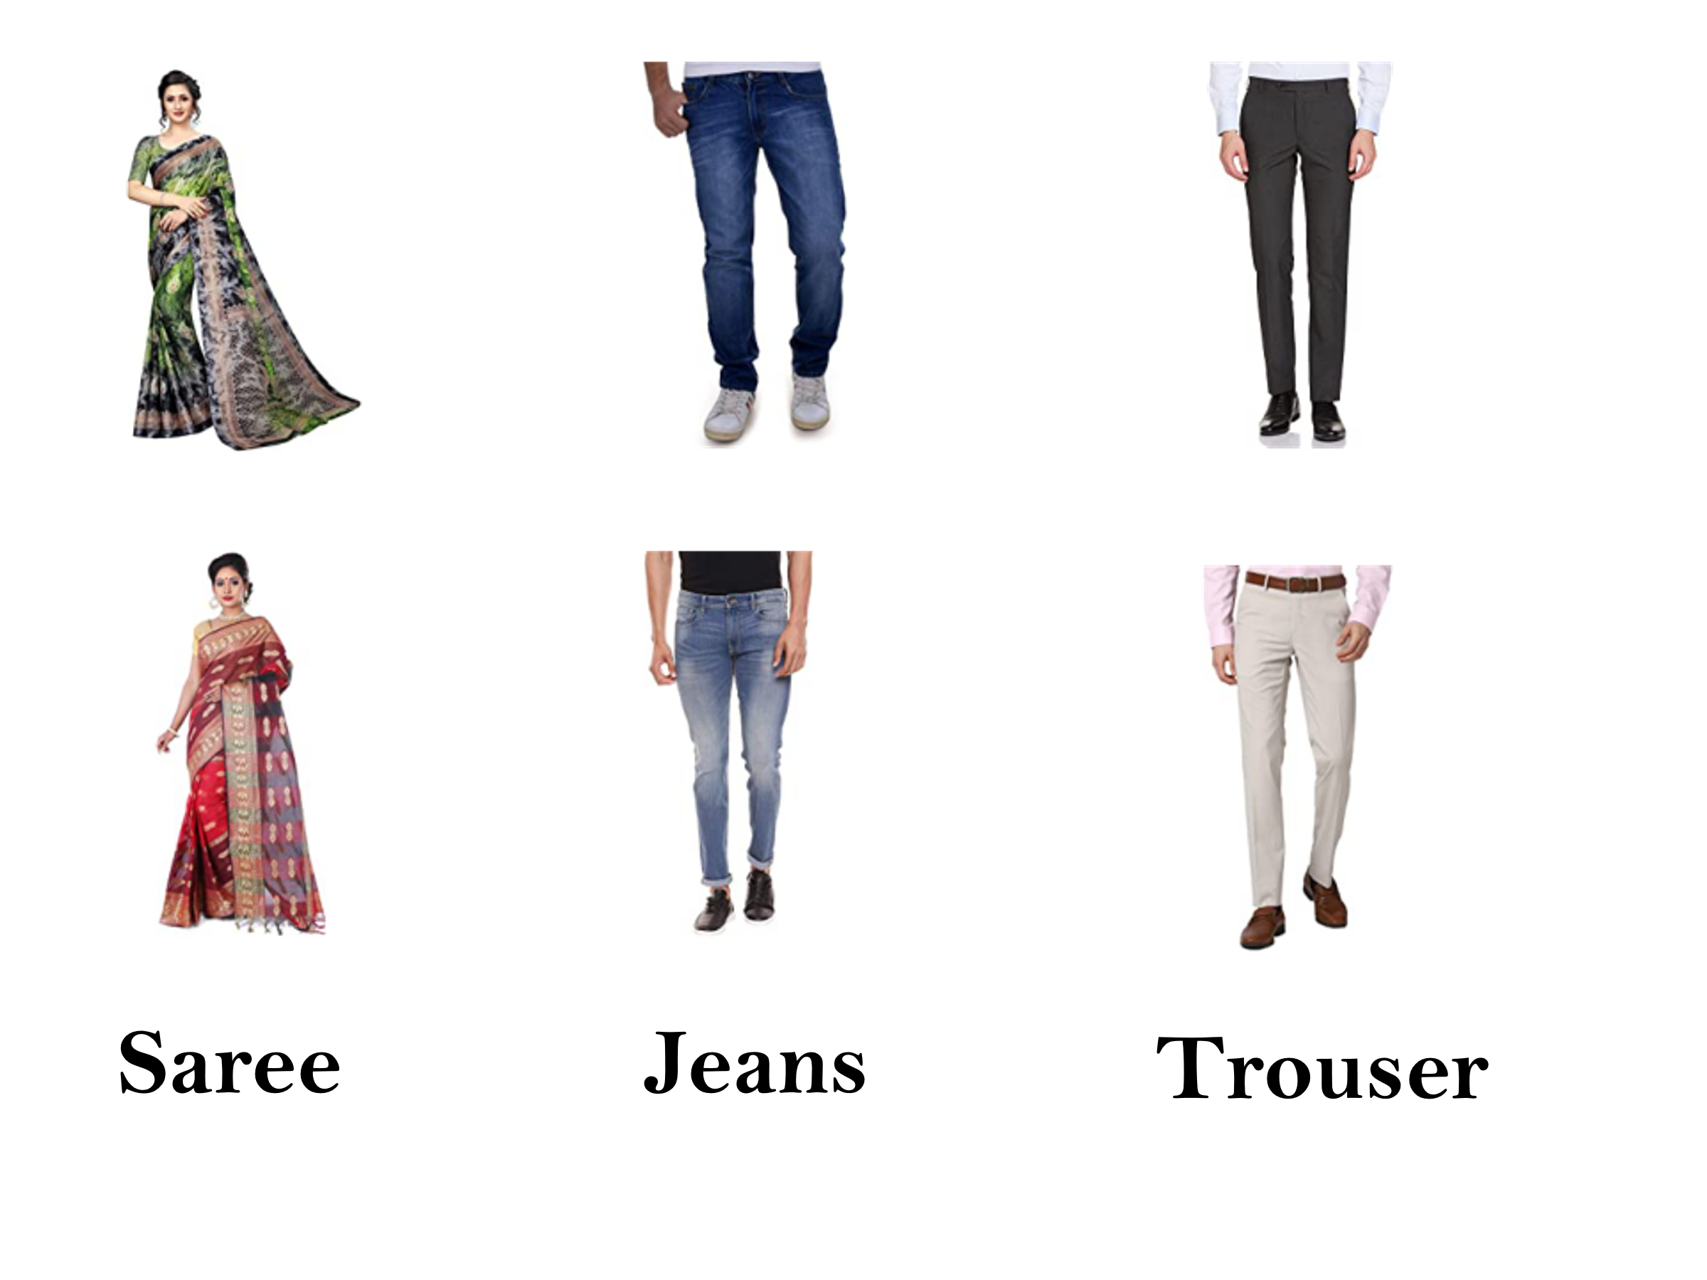

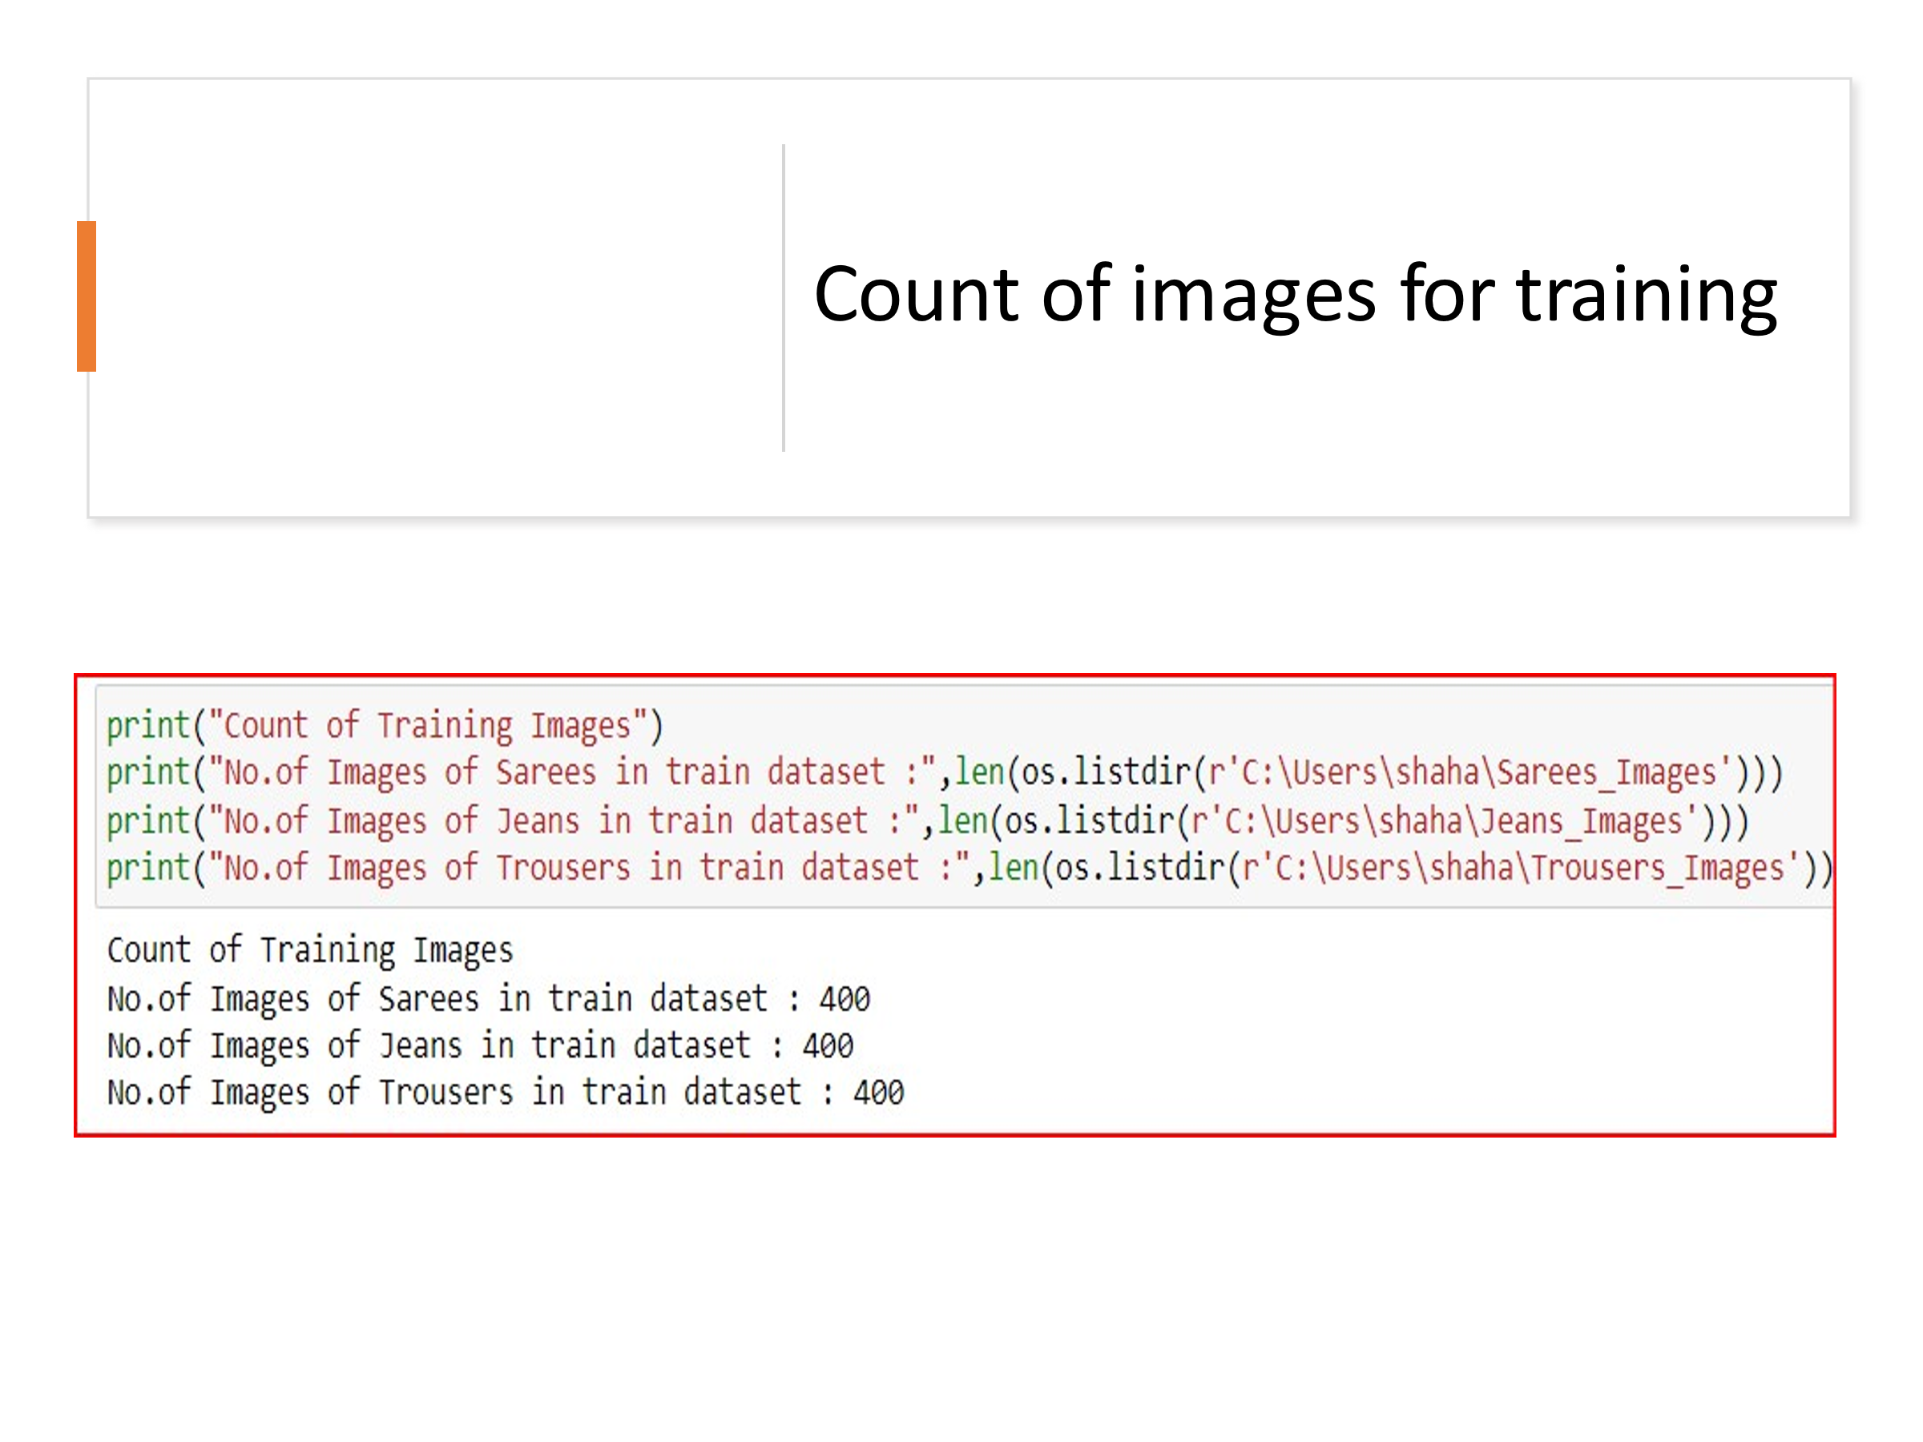

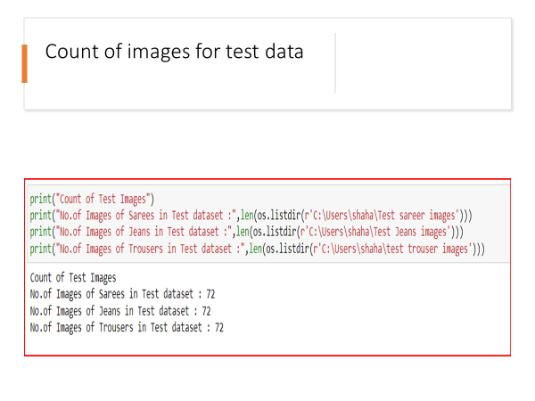

Model Building Phase:

First, we will be defining dimensions of images and other parameters too. Then for data augmentation we defined training and testing set.

After the data collection and preparation is done, I have built an image classification model that will classify between these 3 categories mentioned as:-

**Saree as ‘0’,**

**Jeans as ‘1’,**

**Trouser as ‘2’.**

First, we will be defining dimensions of images and other parameters too. Then for data augmentation we defined training and testing set.

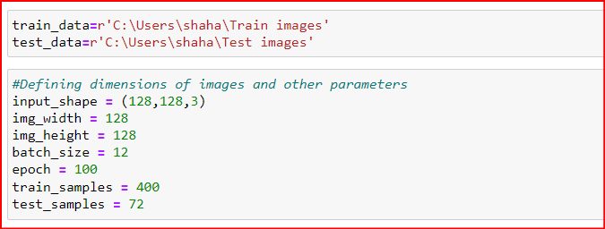

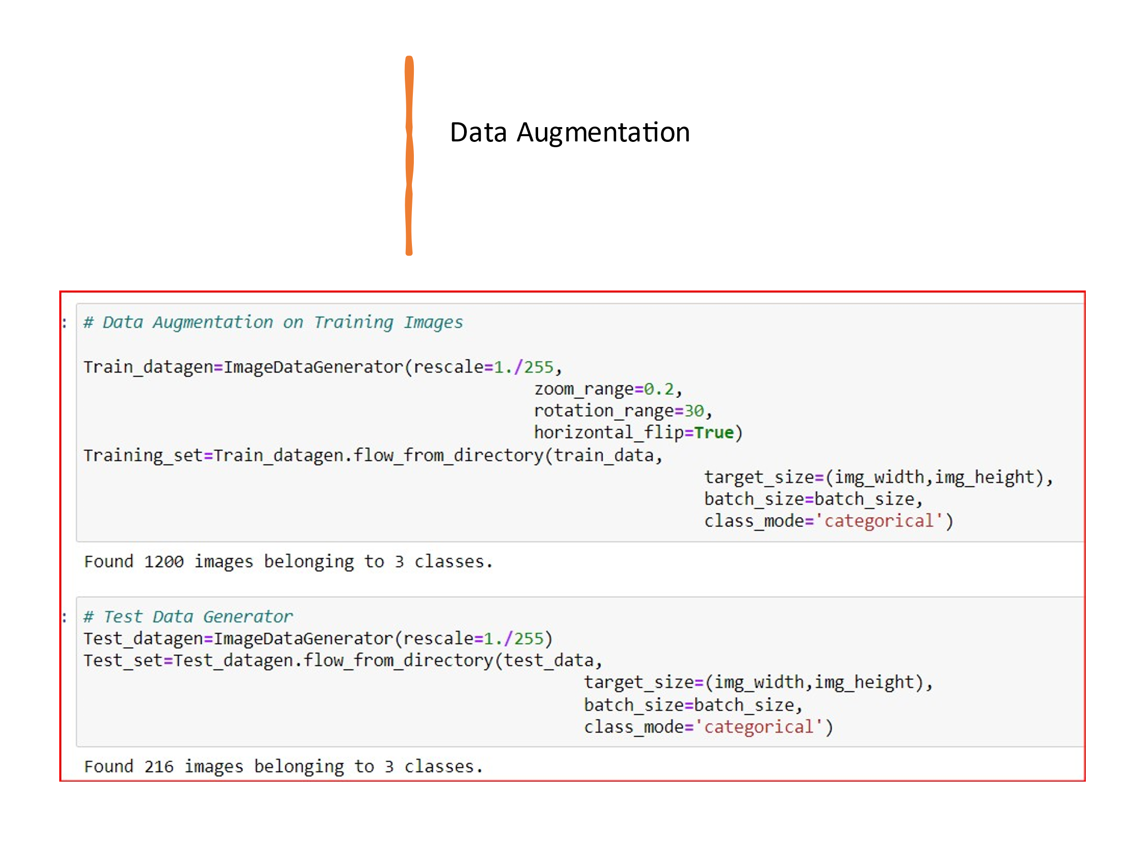

Creating Model using Convolution Neural Network

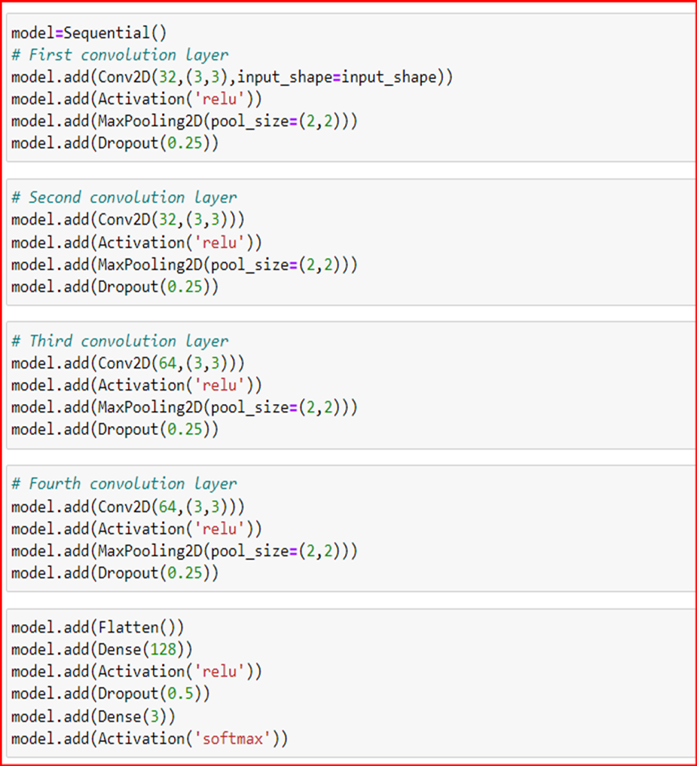

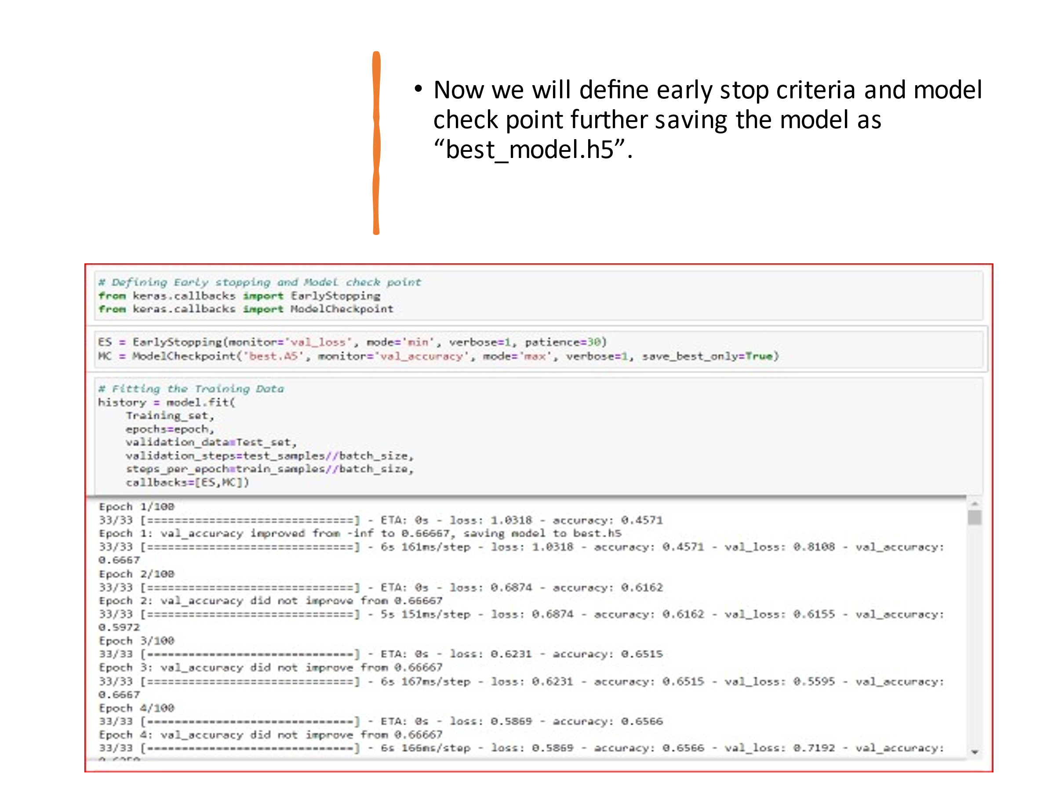

Next, we have loaded our saved model and predicted results for test images. We have printed the results for all the images in test folder.

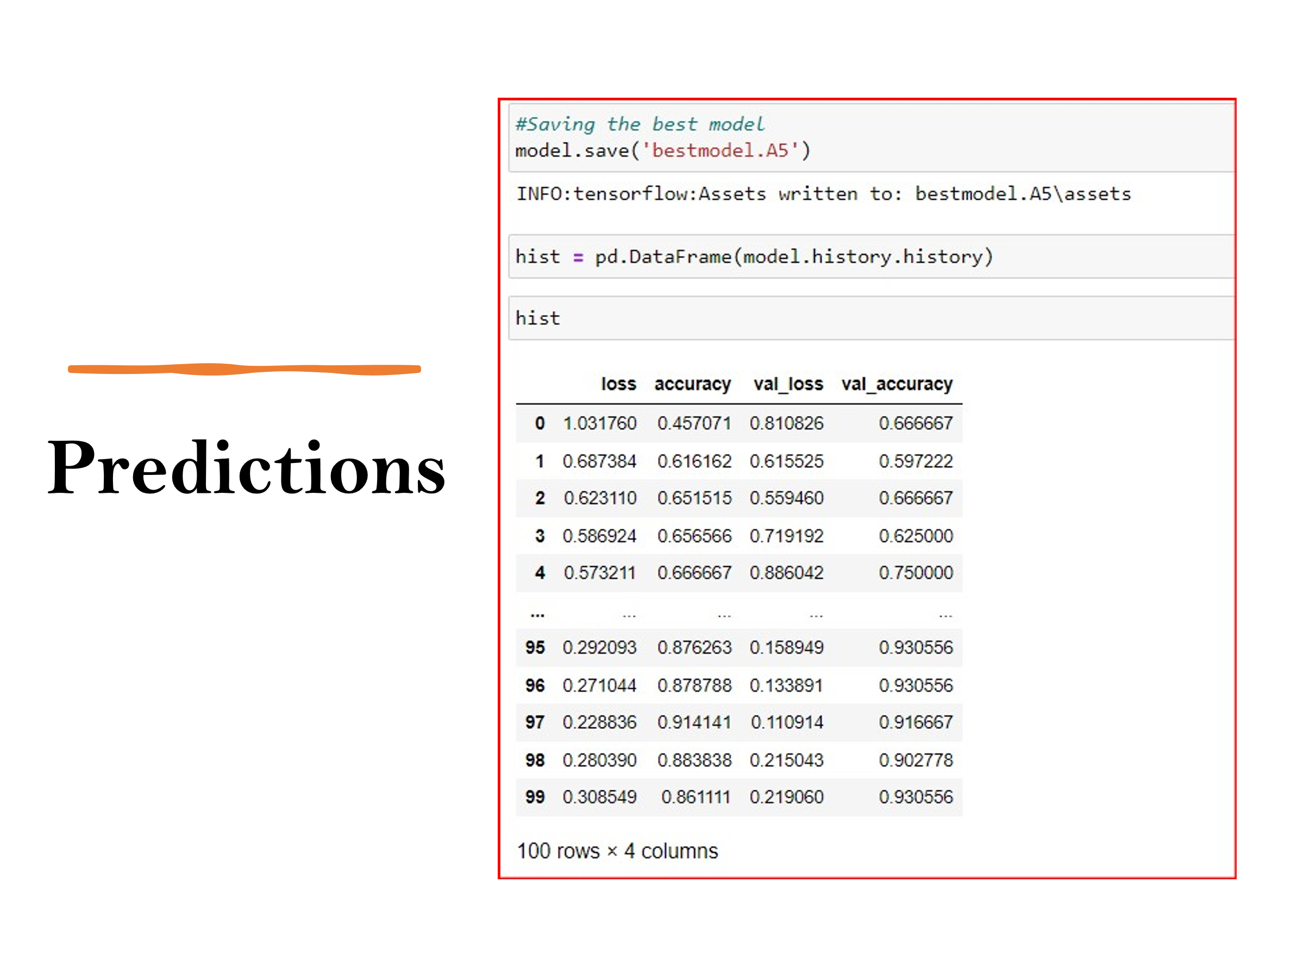

The result is printed as shown below:

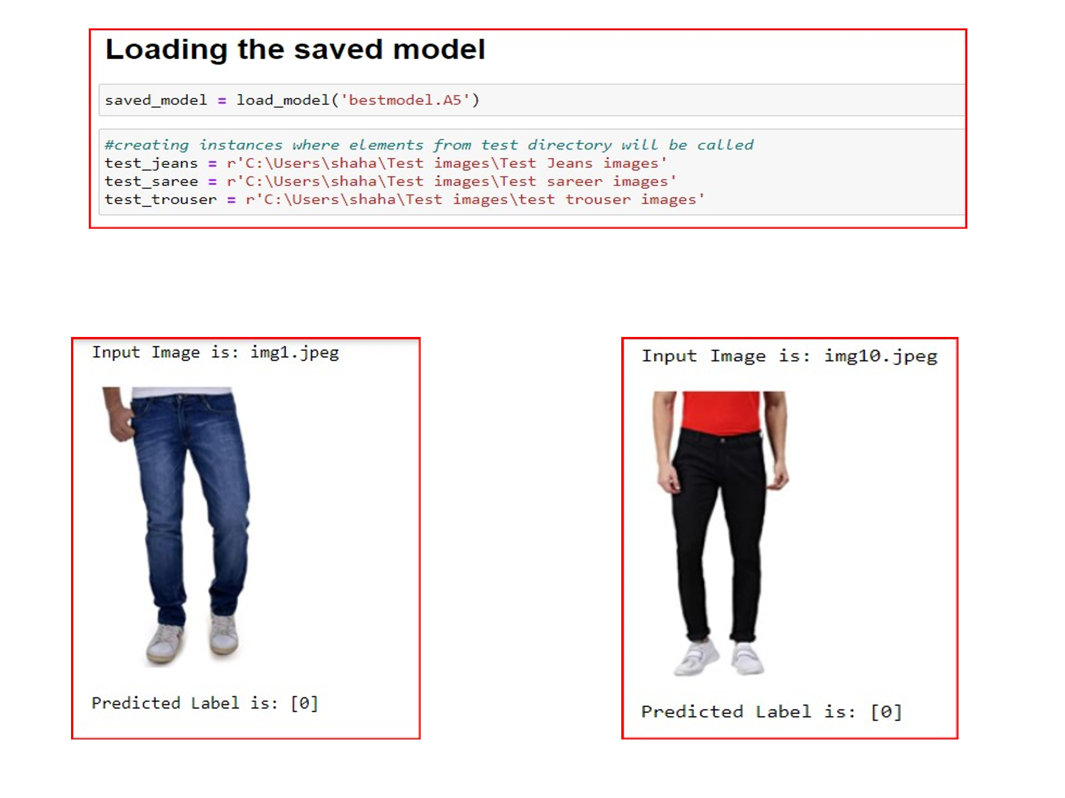

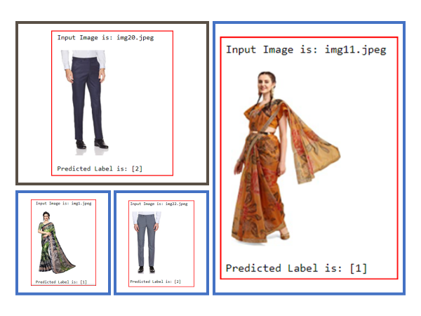

CONCLUSIONS

### In conclusion, this project is about image classification by using deep learning via framework TensorFlow. The roles of epochs in CNN were able to control accuracy and prevent any problems such as overfitting. Thus, we were able to classify the three categories of images with an accuracy of 90.91%.

### In this project I was able to learn about Deep Neural Networks and Convolution Neural Network. I also learned techniques to scrap and download images in the specified directory using code.

THANK YOU!!!